2023 Fee Structure

JANUARY TO NOVEMBER (11 MONTHS)

REGISTRATION will be paid yearly to cover any extra cost
GRADE/  CLASS | REG  YEARLY | FEES  PER MONTH | FEES PER YEAR
BUTTERFLIES (2yrs-3yrs) | 1200.00 | 1300.00 | 14 300.00
EAGLES  (3yrs-4yrs) | 1200.00 | 1400.00 | 15 400.00
LIONS  (4yrs-5yrs) | 1200.00 | 1500.00 | 16 500.00
ELEPHANTS (5yrs-6yrs) | 1200.00 | 1600.00 | 17 600.00
GRADE 1 | 1200.00 | 2950.00 | 32 450.00
GRADE 2 | 1200.00 | 2950.00 | 32 450.00
GRADE 3 | 1200.00 | 2950.00 | 32 450.00
GRADE 4 | 1200.00 | 2950.00 | 32 450.00
GRADE 5 | 1200.00 | 2950.00 | 32 450.00
GRADE 6 | 1200.00 | 2950.00 | 32 450.00
GRADE 7 | 1200.00 | 2950.00 | 32 450.00

C/O of Kingfisher
& Kestrell Street
Hochland Park
Windhoek. NAMIBIA

P. O. Box 98505
Pelican Square
Windhoek, NAMIBIA

Phone: 061-254235 or
0818766776
E-mail: hacs@iway.na
secretary@hcs.edu.na

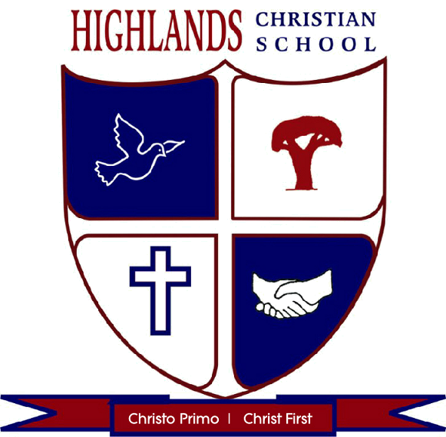

YOUR private
School of Choice

PROSPECTUS 2023


INTRODUCTION:

“HIGHLANDS CHRISTIAN SCHOOL” understands that Education does not begin and end with information accumulation, it also has to transcend into the transformation of each individual child on his or her journey to adulthood. Therefore the school’s main objective is to provide a Christ-centered environment where children are equipped and nurtured into becoming well balanced, disciplined human beings who walk with excellence, integrity and honour in our society. Producing young responsible adults with the necessary social skills and love for God and their fellow human beings is a fundamental part of what we aim to accomplish with our students.

- REQUIREMENTS:
- Application Form & Entrance test Fee of N$100.00
(non-refundable)
- Any learner who is to be enrolled at HIGHLANDS CHRISTIAN SCHOOL needs to write an Entrance Test to determine if HCS is the most suitable education institution for him or her.
- Please do submit (with application) certified copies of the following documents to the school.
- The Latest School Report.
- The Birth Certificate of the Child.
- 2 Passport Photo’s of the Child.
- ID / Passport of Parents.
- Municipality Bill or Rental contract.

- PAYMENTS:
- To secure a place for your child, registration fee of N$1200.00 (non-refundable) is payable upon acceptance of your child to the school.
- January fee is payable before or on the first day of school in January 2023.
- School fees are paid over 11 months for Pre-Schoolers & Grades 1—7.
- Discount of 10% is given when annual fees are paid in full before 05th March every year.
- School fees should be paid on or before the 1st of every month.
- 1.25% interest is charged on all outstanding amounts.

- EDUCATION & SUBJECTS OFFERED:
  - PRE-SCHOOL CLASSES:
- BEES : 1 – 2 YEARS of age
- BUTTERFLIES : 2 – 3 YEARS of age
POTTY TRAINED AND NO BOTTLES
- EAGLES : 3 - 4 YEARS of age
- LIONS : 4 - 5 YEARS of age

Lunch @12h00 will be provided to all
PRE-SCHOOL learners from Monday to Friday. Parents should pack breakfast and snacks for break time and after school. Learners can stay at school until 17H30.

  - JUNIOR PRIMARY SCHOOL:
GRADE 0
GRADE 1 - 3
- PROMOTION (P) SUBJECTS:
- ENGLISH 1ST LANGUAGE
- AFRIKAANS 2ND LANGUAGE
- MATHEMATICS
- ENVIRONMENTAL STUDIES
- BIBLICAL STUDIES
- HANDWRITING
- SUPPORT SUBJECTS:
- ARTS
- PHYSICAL EDUCATION
- INFORMATION & COMMUNICATION

  - SENIOR PRIMARY:
GRADE 4 – 7
- PROMOTION (P) SUBJECTS:
- ENGLISH 1ST LANGUAGE
- AFRIKAANS 2ND LANGUAGE
- MATHEMATICS
- SOCIAL STUDIES
- NATURAL SCIENCE & HEALTH EDUCATION
- BIBLICAL STUDIES

- SUPPORT SUBJECTS:
- LIFE SKILLS
- ARTS

- PHYSICAL EDUCATION (P.E)
- INFORMATION & COMMUNICATION
- ADDITIONAL SERVICE

- FREE LEARNERS SUPPORT CLASSES and homework monitoring
Our teachers work (Monday and Tuesday) from 13h30 - 15h00 to give extra free classes to learners who experience difficulty in grasping the content of subjects, besides extra mural activities. Teachers will also assist learners with homework during this time. Learners can be pick-up @ 15h00. No classes on Friday. Parents should pack lunch or make use of our tuck-shop.

- HOMEWORK SUPERVISION: JUNIOR AND SENIOR PRIMARY learners can be kept at school from 15h00 – 17h30 under the supervision with a N$300.00 and another N$300.00 for cooked meals. N$500.00 for outside learners

- TUCK-SHOP:
This service is available to the learners during both break times (10h00 to 10h30) and at the end of school day from 13h00 till 14h00. Tuck shop will be available every day. Parents need to order the day before.

ARTS: Grade 0 – Grade 7

LANGUAGES: English First Language and Afrikaans Second Language are compulsory for our learners.
EXTRA MURAL ACTIVITIES: Dancing, Chess, Swimming and many more. Parents can arrange for learners to stay until 17h30 at the latest. Only a caretaker will stay with them after 15h00. French Foreign Language is optional and part of our extra mural.

